* Column Chart
* Bar Graph
* Line Graph
* Dual Axis Chart
* Area Chart
* Stacked Bar Graph
* Mekko Chart
* Pie Chart
* Scatter Plot Chart
* Bubble Chart
* Waterfall Chart
* Funnel Chart
* Bullet Chart
* Heat Map

You and I sift through a lot of data for our jobs. Data about website performance, sales performance, product adoption, customer service, marketing campaign results ... the list goes on.

When you manage multiple content assets, such as social media or a blog, with multiple sources of data, it can get overwhelming.What should you be tracking? What actually matters? [**How do you visualize and analyze the data**](https://academy.hubspot.com/courses/business-analytics?utm_source=marketing_blog&utm_medium=blog&utm_campaign=business_analytics_course) so you can extract insights and actionable information?

More importantly, how can you make reporting more efficient when you're busy working on multiple projects at once?

One of the struggles that slows down my own reporting and analysis is understanding what types of graphs to use -- and why. That's because choosing the wrong visual aid or simply defaulting to the most common type of data visualization could cause confusion with the viewer or lead to mistaken data interpretation.

To create charts that clarify and provide the right canvas for analysis, you should first understand the reasons why you might need a chart. In this post, I'll cover five questions to ask yourself when choosing a chart for your data.

Then, I'll give an overview of 14 different types of charts you have at your disposal.

**5 Questions to Ask When Deciding Which Type of Chart to Use**

1. Do you want to compare values?

Charts are perfect for comparing one or many value sets, and they can easily show the low and high values in the data sets. To create a comparison chart, use these types of graphs:

* Column
* Mekko
* Bar
* Pie
* Line
* Scatter Plot
* Bullet

2. Do you want to show the composition of something?

Use this type of chart to show how individual parts make up the whole of something, such as the device type used for mobile visitors to your website or total sales broken down by sales rep.

To show composition, use these charts:

* Pie
* Stacked Bar
* Mekko
* Stacked Column
* Area
* Waterfall
* 3. Do you want to understand the distribution of your data?
* Distribution charts help you to understand outliers, the normal tendency, and the range of information in your values.
* Use these charts to show distribution:
* Scatter Plot
* Mekko
* Line
* Column
* Bar
* 4. Are you interested in analyzing trends in your data set?
* If you want to know more information about how a data set performed during a specific time period, there are specific chart types that do extremely well.
* You should choose a:
* Line
* Dual-Axis Line
* Column
* 5. Do you want to better understand the relationship between value sets?
* Relationship charts are suited to showing how one variable relates to one or numerous different variables. You could use this to show how something positively effects, has no effect, or negatively effects another variable.
* When trying to establish the relationship between things, use these charts:
* Scatter Plot
* Bubble
* Line

Featured Resource: [**The Marketer's Guide to Data Visualization**](https://offers.hubspot.com/data-visualization-guide?hubs_post-cta=header)

[**Download this free data visualization guide**](https://offers.hubspot.com/data-visualization-guide?hubs_post-cta=imagebottom) to learn which graphs to use in your marketing, presentations, or project -- and how to use them effectively.

**14 Different Types of Graphs and Charts for Presenting Data**

To better understand each chart and how they can be used, here's an overview of each type of chart.

1. Column Chart

A column chart is used to show a comparison among different items, or it can show a comparison of items over time. You could use this format to see the revenue per landing page or customers by close date.

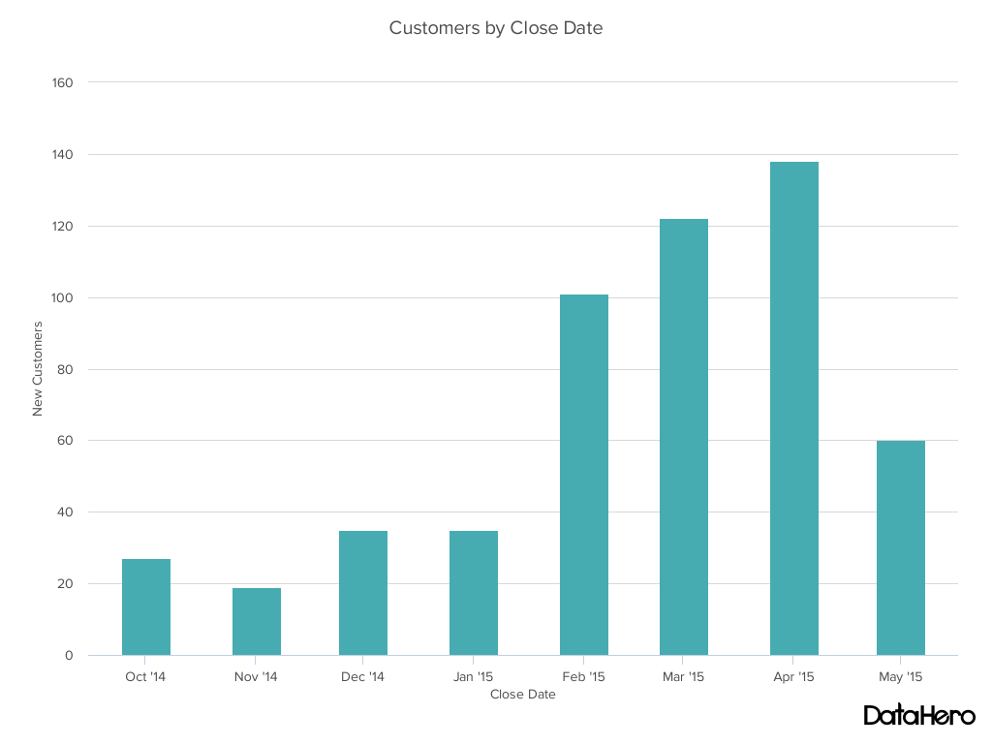

**Design Best Practices for Column Charts:**

* **Use consistent colors** throughout the chart, selecting accent colors to highlight meaningful data points or changes over time.
* **Use horizontal labels** to improve readability.
* **Start the y-axis at 0** to appropriately reflect the values in your graph.

2. Bar Graph

A bar graph, basically a horizontal column chart, should be used to avoid clutter when one data label is long or if you have more than 10 items to compare. This type of visualization can also be used to display negative numbers.

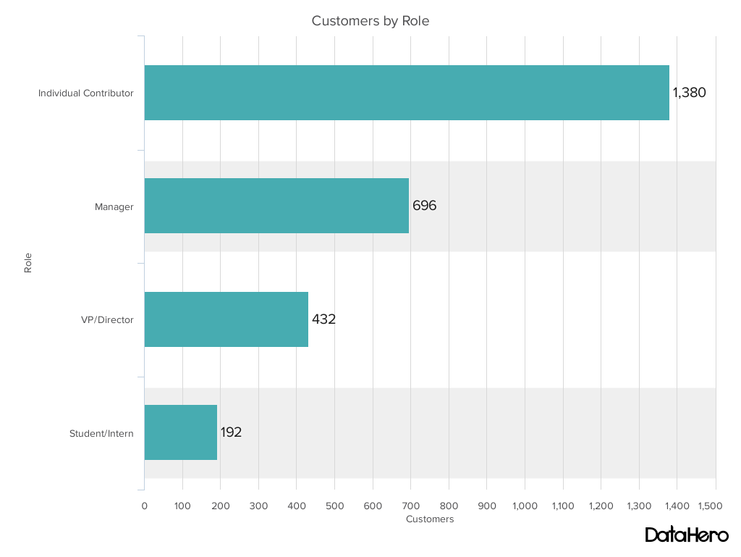

**Design Best Practices for Bar Graphs:**

* **Use consistent colors** throughout the chart, selecting accent colors to highlight meaningful data points or changes over time.
* **Use horizontal labels** to improve readability.
* **Start the y-axis at 0** to appropriately reflect the values in your graph.

3. Line Graph

A line graph reveals trends or progress over time and can be used to show many different categories of data. You should use it when you chart a continuous data set.

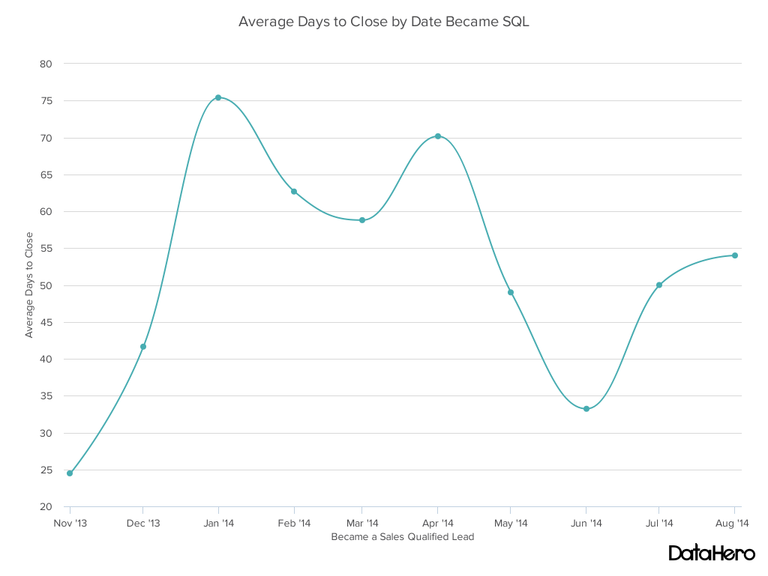

**Design Best Practices for Line Graphs:**

* **Use solid lines only.**
* **Don't plot more than four lines** to avoid visual distractions.
* **Use the right height** so the lines take up roughly 2/3 of the y-axis' height.

4. Dual Axis Chart

A dual axis chart allows you to plot data using two y-axes and a shared x-axis. It's used with three data sets, one of which is based on a continuous set of data and another which is better suited to being grouped by category. This should be used to visualize a correlation or the lack thereof between these three data sets.

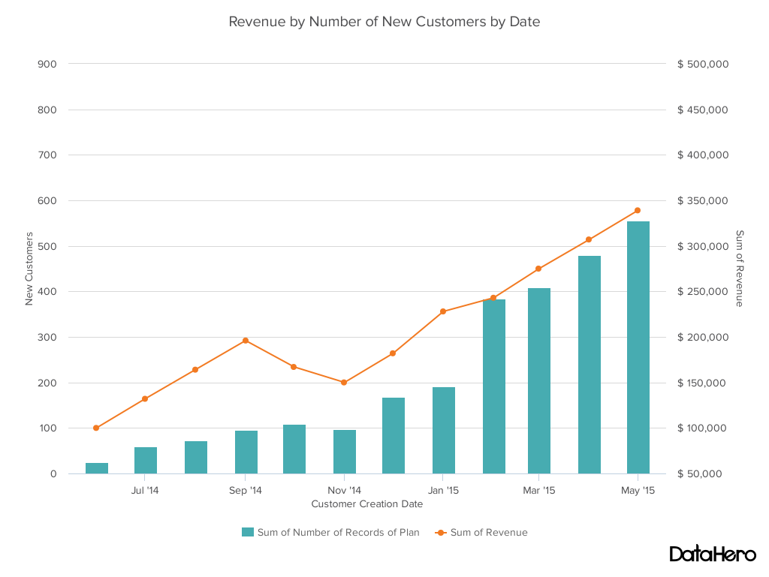

**Design Best Practices for Dual Axis Charts:**

* **Use the y-axis on the left side for the primary variable** because brains are naturally inclined to look left first.
* **Use different graphing styles** to illustrate the two data sets, as illustrated above.
* **Choose contrasting colors** for the two data sets.

5. Area Chart

An area chart is basically a line chart, but the space between the x-axis and the line is filled with a color or pattern. It is useful for showing part-to-whole relations, such as showing individual sales reps' contribution to total sales for a year. It helps you analyze both overall and individual trend information.

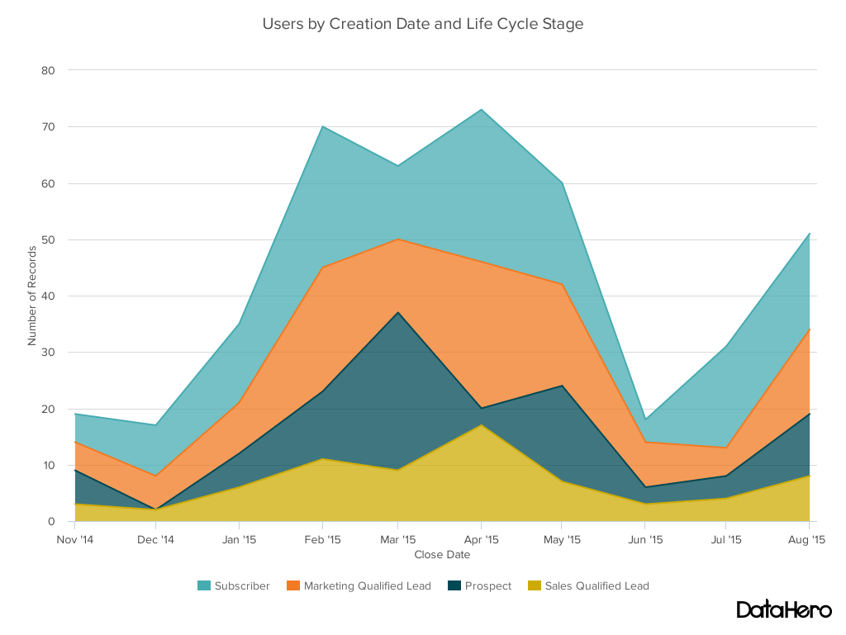

**Design Best Practices for Area Charts:**

* **Use transparent colors** so information isn't obscured in the background.
* **Don't display more than four categories** to avoid clutter.
* Organize highly variable data at the top of the chart to **make it easy to read.**

6. Stacked Bar Chart

This should be used to compare many different items and show the composition of each item being compared.

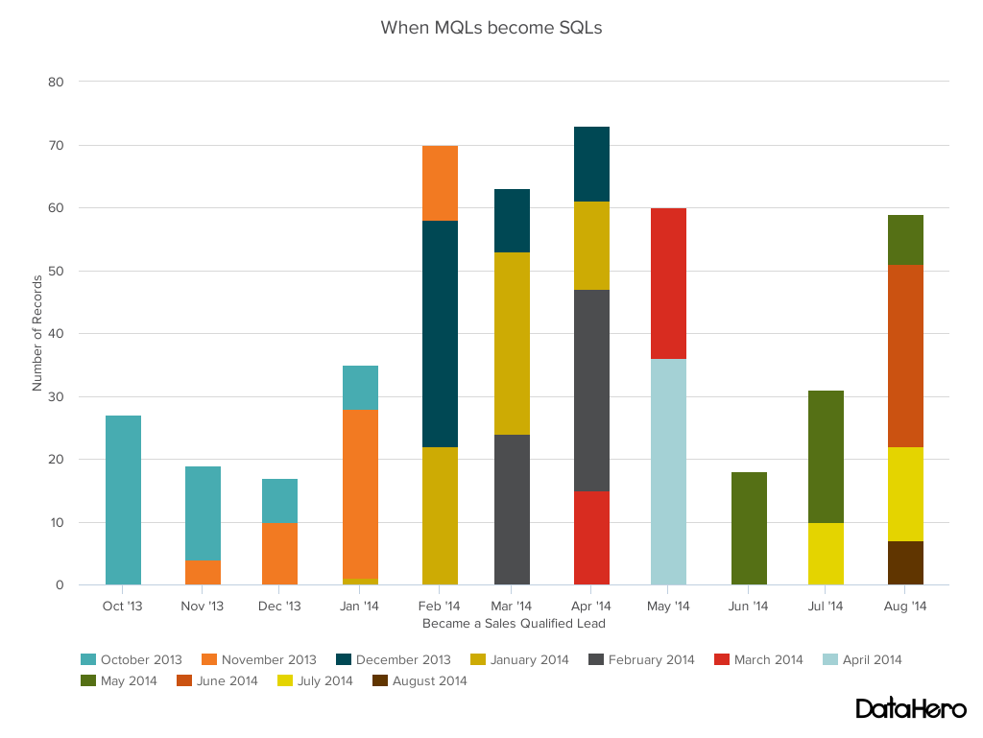

**Design Best Practices for Stacked Bar Graphs:**

* Best used to illustrate **part-to-whole relationships.**
* Use **contrasting colors** for greater clarity.
* **Make chart scale large enough** to view group sizes in relation to one another.

7. Mekko Chart

Also known as a marimekko chart, this type of graph can compare values, measure each one's composition, and show how your data is distributed across each one.

It's similar to a stacked bar, except the mekko's x-axis is used to capture another dimension of your values -- rather than time progression, like column charts often do. In the graphic below, the x-axis compares each city to one another.

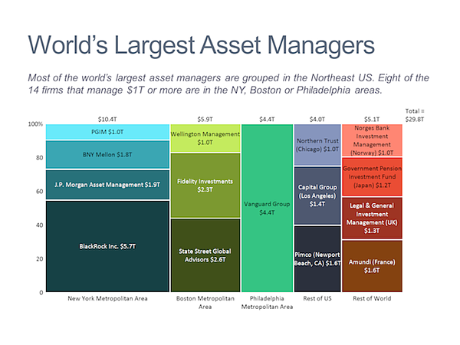

Image via **[Mekko Graphics](https://www.mekkographics.com/portfolio-item/deal-profile/" \t "_blank)**

**Design Best Practices for Mekko Charts:**

* **Vary you bar heights** if the portion size is an important point of comparison.
* **Don't include too many composite values** within each bar. you might want to reevaluate how to present your data if you have a lot.
* **Order your bars** from left to right in such a way that exposes a relevant trend or message.

8. Pie Chart

A pie chart shows a static number and how categories represent part of a whole -- the composition of something. A pie chart represents numbers in percentages, and the total sum of all segments needs to equal 100%.

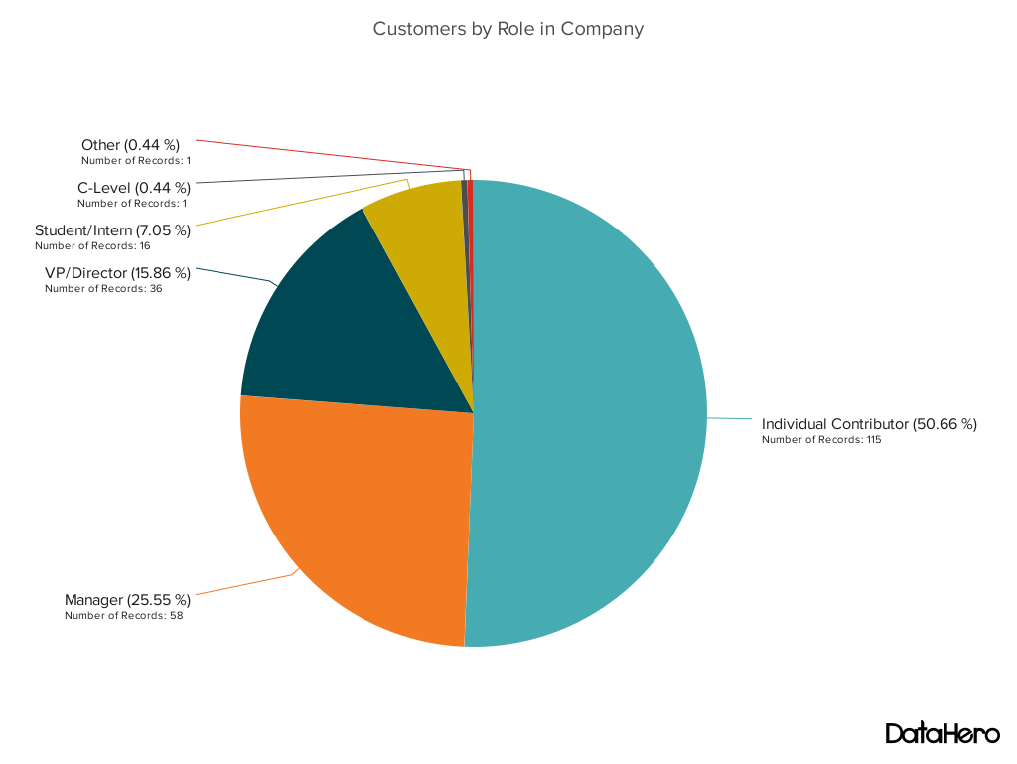

**Design Best Practices for Pie Charts:**

* **Don't illustrate too many categories** to ensure differentiation between slices.
* Ensure that the slice values **add up to 100%.**
* **Order slices** according to their size.

9. Scatter Plot Chart

A scatter plot or scattergram chart will show the relationship between two different variables or it can reveal the distribution trends. It should be used when there are many different data points, and you want to highlight similarities in the data set. This is useful when looking for outliers or for understanding the distribution of your data.

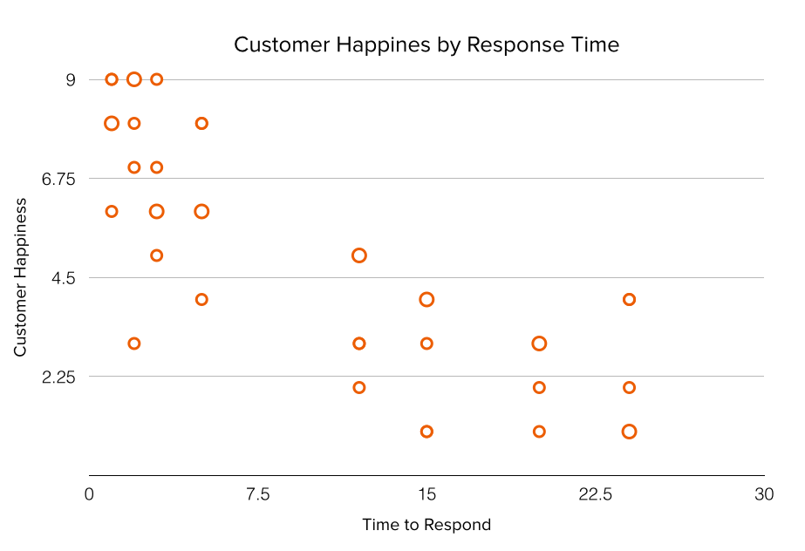

**Design Best Practices for Scatter Plots:**

* **Include more variables**, such as different sizes, to incorporate more data.
* **Start y-axis at 0** to represent data accurately.
* If you use **trend lines**, only use a maximum of two to make your plot easy to understand.

10. Bubble Chart

A bubble chart is similar to a scatter plot in that it can show distribution or relationship. There is a third data set, which is indicated by the size of the bubble or circle.

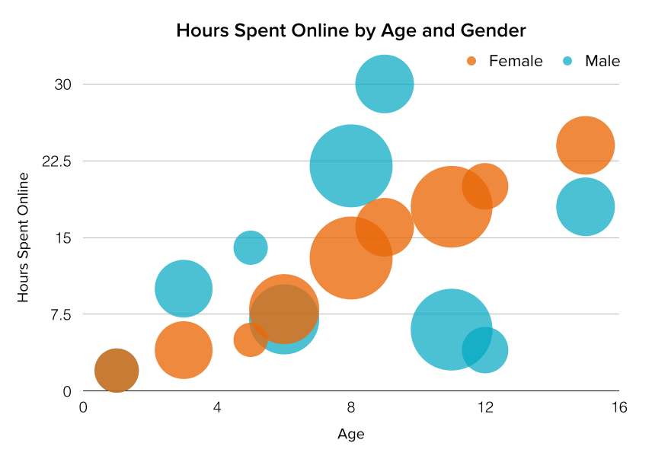

**Design Best Practices for Bubble Charts:**

* **Scale bubbles according to area**, not diameter.
* Make sure **labels are clear and visible.**
* **Use circular shapes** only.

11. Waterfall Chart

A waterfall chart should be used to show how an initial value is affected by intermediate values -- either positive or negative -- and resulted in a final value. This should be used to reveal the composition of a number. An example of this would be to showcase how overall company revenue is influenced by different departments and leads to a specific profit number.

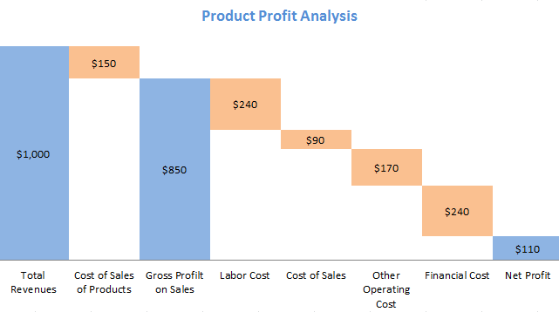

*Chart via****[Baans Consulting](http://baansconsulting.com/?p=2303" \t "_blank)***

**Design Best Practices for Waterfall Charts:**

* **Use contrasting colors** to highlight differences in data sets.
* Choose warm colors to indicate increases and cool colors to indicate decreases.

12. Funnel Chart

A funnel chart shows a series of steps and the completion rate for each step. This can be used to track the sales process or the conversion rate across a series of pages or steps.

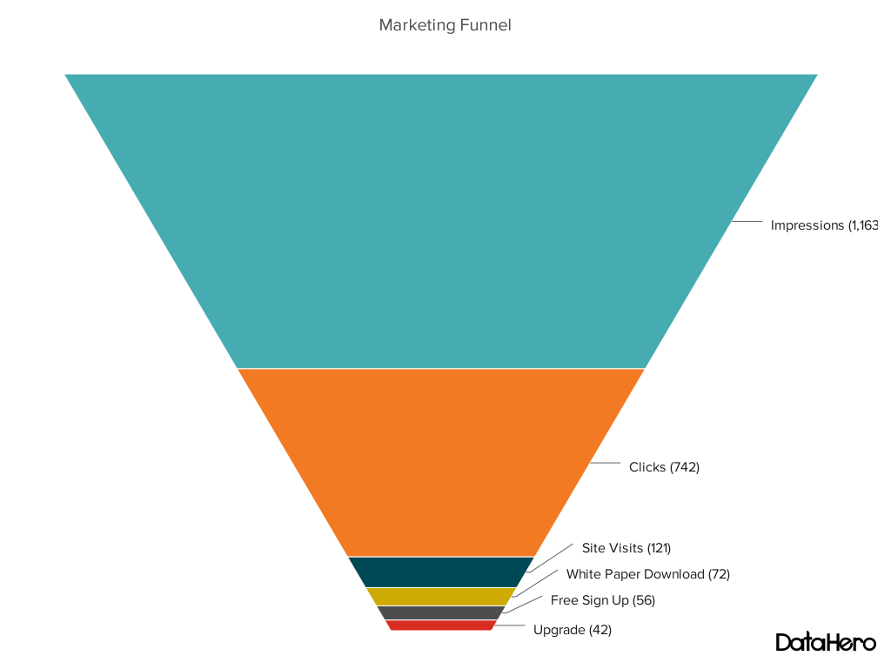

**Design Best Practices for Funnel Charts:**

* **Scale the size of each section** to accurately reflect the size of the data set.
* Use **contrasting colors** or **one color** in gradating hues, from darkest to lightest as the size of the funnel decreases.

13. Bullet Graph

A bullet graph reveals progress toward a goal, compares this to another measure, and provides context in the form of a rating or performance.

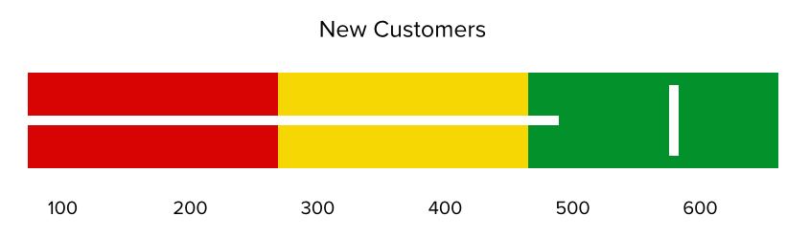

**Design Best Practices for Bullet Graphs:**

* **Use contrasting colors** to highlight how the data is progressing.
* **Use one color** in different shades to gauge progress.

14. Heat Map

A heat map shows the relationship between two items and provides rating information, such as high to low or poor to excellent. The rating information is displayed using varying colors or saturation.

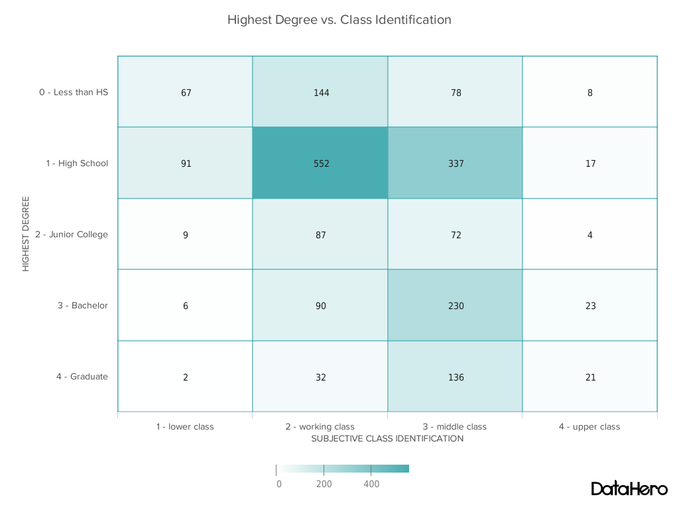

**Design Best Practices for Heat Map:**

* **Use a basic and clear map outline** to avoid distracting from the data.
* **Use a single color** in varying shades to show changes in data.
* **Avoid using multiple patterns.**

**By Shafique Gajdhar,**[**Fusion Charts**](https://www.fusioncharts.com/).

Data speaks best through visuals, not words – so believes renowned data journalist and TEDtalks speaker, David McCandless. According to him, [80%](https://www.youtube.com/watch?v=5Zg-C8AAIGg) of all that we learn gets imbibed visually, and research would have to agree.

Three groups of economists participated in a [study](https://econsultancy.com/blog/67465-data-visualization-14-jaw-dropping-examples) where they were given a dataset and asked everyone the same question. Of the group armed with only the data and standard statistical analysis, 72% got the answer wrong. Another was provided the data, the analysis, and a chart as well – errors dropped to 61%.

But (and here’s the catch) the final group had only the go-to chart. And only 3% answered incorrectly!

The power of charts to aid accurate interpretation is, to put it plainly, mindblowing. That’s why users across the globe are increasingly looking at charts (or graphs) and pictorial representations to maximize the information at hand.

However, it could be a challenge to [align visualizations to available datasets correctly](https://www.fusioncharts.com/charting-best-practices/selecting-the-right-chart/), and the ultimate business needs.

The same numbers can be shown in several ways, and when creating a dashboard, multiple charts must weave into a seamless fabric that together tells a story. This requires a clear understanding of information and what it must achieve: does a visualization need to highlight differences? Should it highlight how one component fits into the whole? Does it need to show distribution? And should individual data points catch the eye?

These questions are, potentially, endless. But answering them accurately could save a lot of effort in the long-run and prevent slip-ups that makes the user question both accuracy and efficacy.

We did a quick breakdown of the most common use cases for data, which could be part of multiple business scenarios, and how best to visualize them.

Begin by asking the fundamental questions –

**Are you comparing data?**

**Yes.**

Are you showing trends – that is, **is the difference over a period** **critical to your story?**  
**Yes.**

Do you have to focus on specific data points?

**Yes.**

A **line chart** is a good alternative as it plots values on the Y axis and time on the X-axis. This could be in hours, days, months, or quarterly intervals, making it a big favorite in marketing & sales. Daily web traffic or quarterly sales, for instance, are perfect for line charts.  
[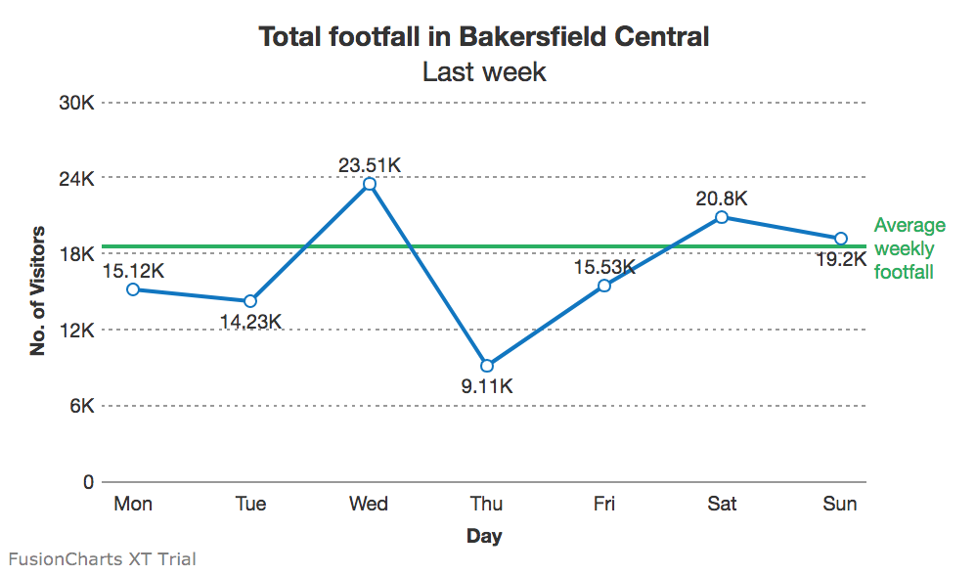](https://www.fusioncharts.com/blog/wp-content/uploads/2018/03/Screen-Shot-2018-03-13-at-9.31.44-PM.png)  
Also, as several lines can be plotted on the same canvas, line charts open possibilities of comparing multiple trends at one go.

**No,** the total volume is more important.

Consider **area charts** – like line charts, these too plot change over time with a significant difference: the space between lines and axis is filled in.  
[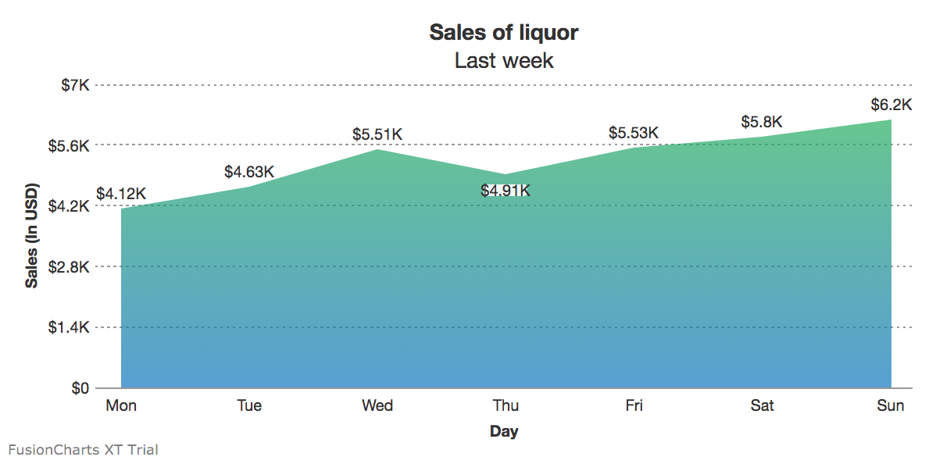](https://www.fusioncharts.com/blog/wp-content/uploads/2018/03/Screen-Shot-2018-03-13-at-9.32.31-PM.png)  
However, more than 4-5 lines on the same chart could be distracting, and it’s difficult to zero in on specific values.

Tooltips, legends, and other contextual information should be intelligently used when creating area charts.

**No,** there is no linear progression of the datasets.

Columns and bars are go-to options for all things comparison, especially if there’s no temporal element involved (though the X axis could show years or month as well).  
[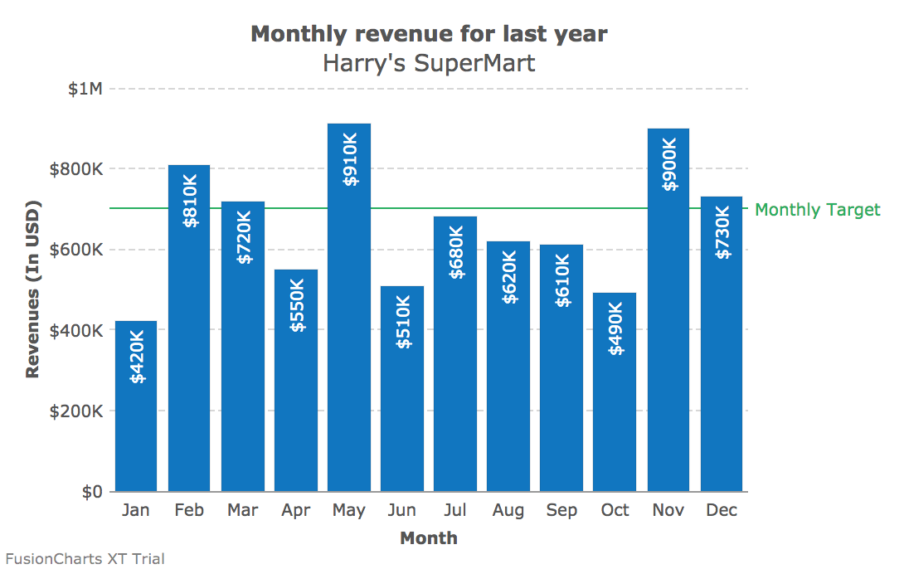](https://www.fusioncharts.com/blog/wp-content/uploads/2018/03/Screen-Shot-2018-03-13-at-9.38.16-PM.png)

However, in the absence of direct lines drawn across the data points, these have emerged popular for non-linear data – population by capital cities, for example, or ROI from different departments.  
[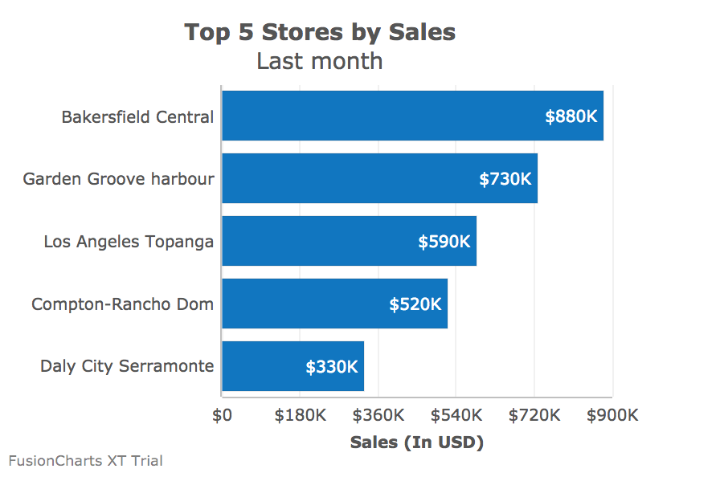](https://www.fusioncharts.com/blog/wp-content/uploads/2018/03/Screen-Shot-2018-03-13-at-9.39.21-PM.png)

**So, column or bar?**

Given the amount of space available, bars and charts perform roughly the same function – however, in case of columns, it’s easier to spot if a data value is below a standard threshold.

**Bar charts** are better suited to show if the data values have reached (or are close to reaching) a particular target. Additionally, bars can also hold a more substantial number of fields, without leading to clutter.

No more than comparison, the chart should accurately portray distribution and let the user draw her conclusions.

**Do you have to show a wide range of datasets?**

**No.**

**Pie-charts** find a place in the majority of visualizations that plot distribution. However, since all the values are shown as percentages of the whole (100%), there’s a limit to the number of segments it should contain.  
[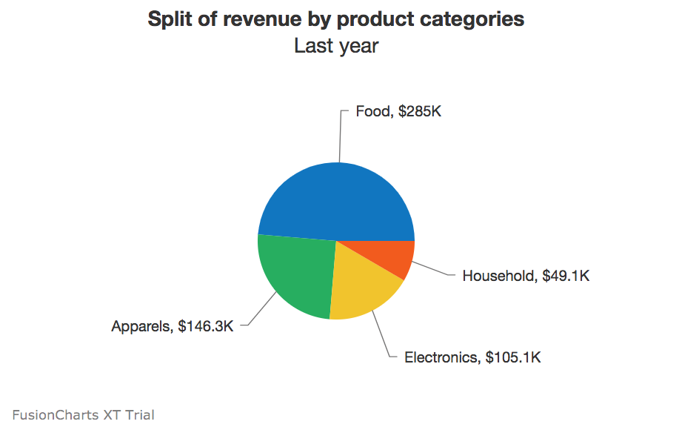](https://www.fusioncharts.com/blog/wp-content/uploads/2018/03/Screen-Shot-2018-03-13-at-9.40.05-PM.png)  
Avoid 3D imagery or tilt, as they interfere with the at-a-glance angle comparison pies are known for.

**Yes.**

Treemaps are marked by their ability to contain a significant amount of data, smartly and efficiently. Different colored rectangles show all the parts of a whole.  
[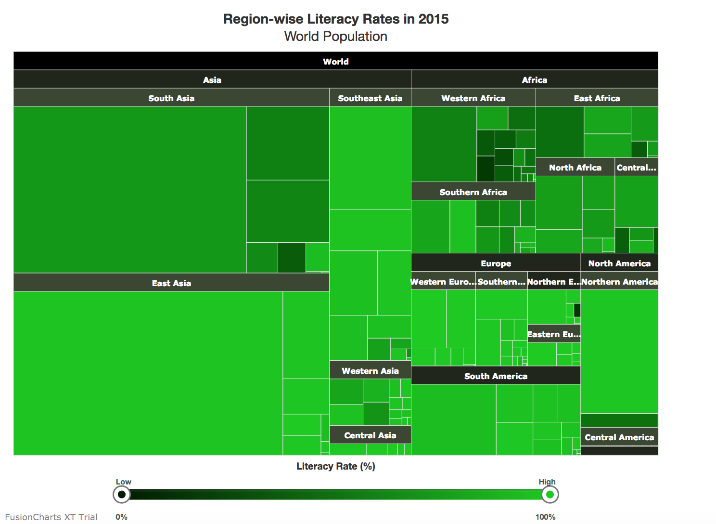](https://www.fusioncharts.com/blog/wp-content/uploads/2018/03/Screen-Shot-2018-03-13-at-9.44.16-PM.png)  
There’s also a comparative aspect to it – because the segments are arranged according to hierarchy, the user can quickly scan and derive insights.

**Is hierarchy crucial to your data, with a clear top-bottom distribution?**

**Yes.**

Another alternative for showing ordered distribution is the pyramid. The uppermost rungs have the lowest values, and the bottom shows the most common instance.  
[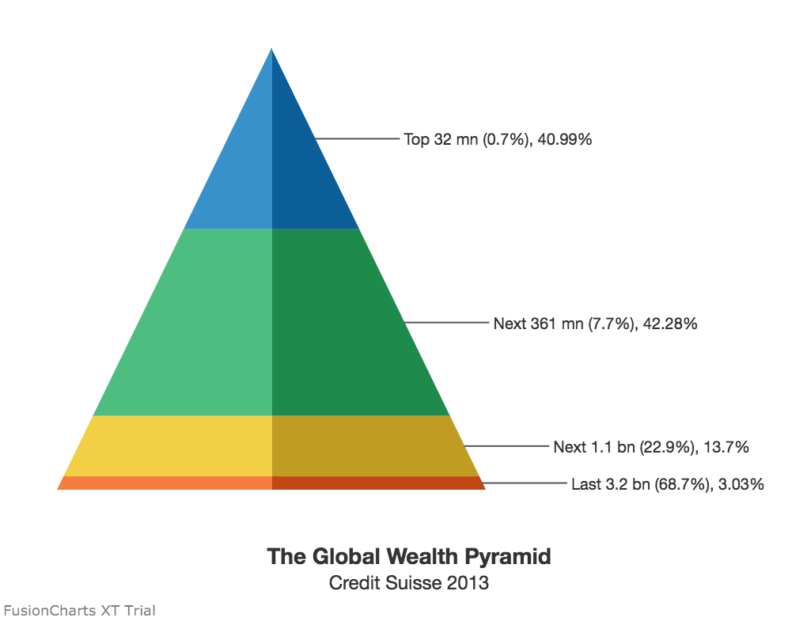](https://www.fusioncharts.com/blog/wp-content/uploads/2018/03/Screen-Shot-2018-03-13-at-9.48.34-PM.png)  
Take the archetypal food pyramid, where the staples are at the bottom, and infrequent components are at the top.

**No,** but the frequency of elements should stand out.

**Word clouds** are explicitly built to suggest frequency and distribution, without highlight the actual numbers. A popular application is for SEO marketers – what are the key terms that pepper user conversations, and which words should take center stage when creating content?

As the deeper intricacies and detailed numbers are essentially ‘blackboxed,’ word clouds could be \*technically\* considered outside the scope of charts. However, they could prove to be a useful visualization tool in real business scenarios.

**But comparison and distribution have to go hand in hand.**

**Stacked bars and columns** pack in a range of data, clearly and accurately, for easy analysis. While individual bars/columns show how the data changes across time, departments, or other factors, the colored ‘stacks’ in each bar/column shows the distribution of components.  
[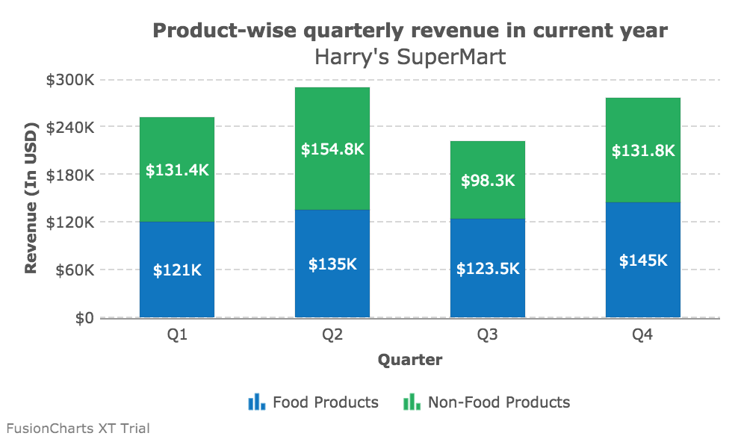](https://www.fusioncharts.com/blog/wp-content/uploads/2018/03/Screen-Shot-2018-03-13-at-9.49.45-PM.png)  
Take the simple instance of illustrating population – columns show how the total number changes year on year, while the stacks in each column indicate the flux in male and female numbers.

**Yes,** and the chart should plot how datasets with disparate units are changing

**Line charts** can also use **two Y axes** to help compare different (but linked) variables, like the number of items sold and net revenues. Not only do these need separate units, but they also depend on a host of other factors – price/per item, for one, or the cost of resources utilized.  
[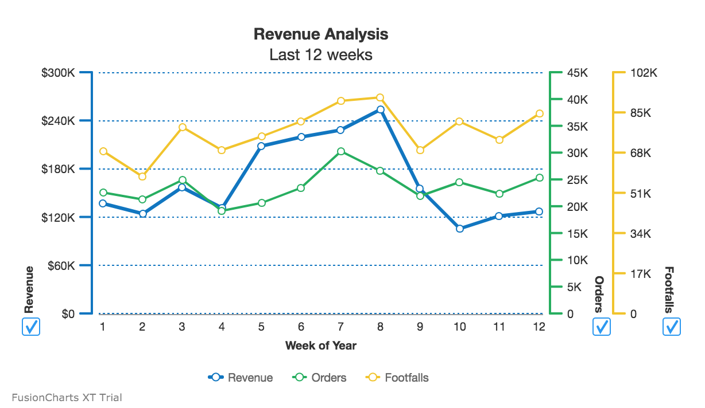](https://www.fusioncharts.com/blog/wp-content/uploads/2018/03/Screen-Shot-2018-03-13-at-9.51.22-PM.png)  
Dual Y-axis maps both datasets on a single canvas, allowing the user to spot possible patterns, combinations, and exceptions.

**Just too many numbers and all of them are critical!**

Charts condense data into the very essentials and let users visualize the bigger picture. No matter how complex, charts must intelligently arrange data and have to include powerful drill-down capabilities if the user is to dive into the fundamentals.

That’s where tables come in – they’re not meant to compete with the bold, colorful visuals of charts and word clouds.

However, they offer a set of unique benefits – data searchability, combining detailed views and summaries in one snapshot, and the inescapable truth that almost everyone knows how to read a table.

**Classifying charts to facilitate better chart selection**

The choice of charts is a function of the questions you’re attempting to answer, the data type, number of variables involved, variable type, the real-estate available and several other reasons. However, if you intend to show relationships, distribution, comparison or composition here’s a simplified representation of chart types mapped to various conditions. ([source](https://www.perceptualedge.com/blog/?p=2080))

**Charts to show Relationships**

[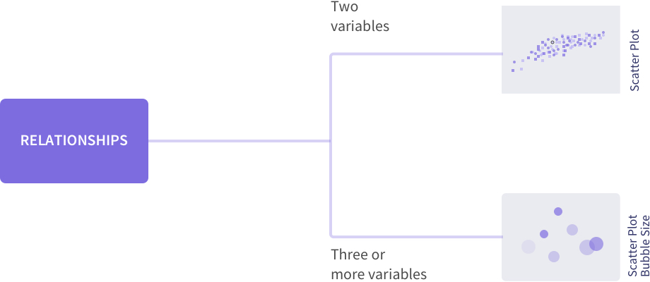](https://www.fusioncharts.com/blog/wp-content/uploads/2018/03/Group-2.jpg)

**Charts to show Distribution**

[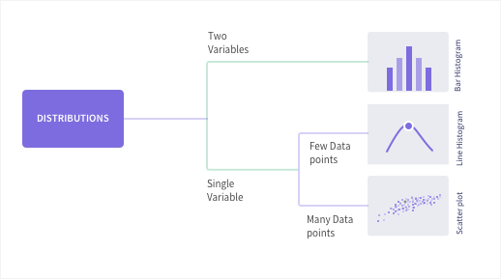](https://www.fusioncharts.com/blog/wp-content/uploads/2018/03/Group-1.jpg)

**Charts for data comparison**

[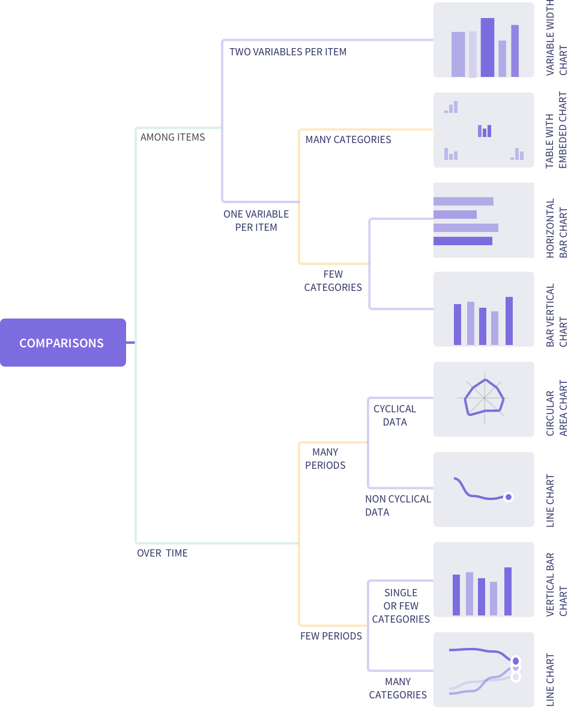](https://www.fusioncharts.com/blog/wp-content/uploads/2018/03/Group-2@2x.jpg)

**Charts to represent composition**

[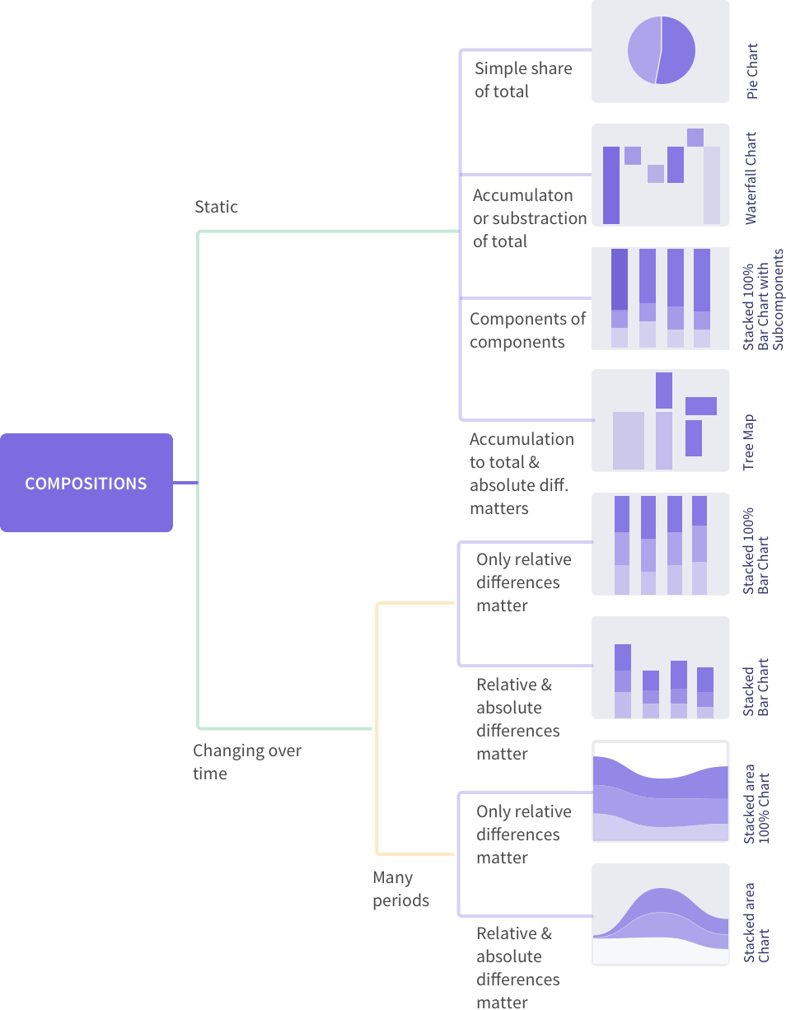](https://www.fusioncharts.com/blog/wp-content/uploads/2018/03/Group.jpg)

**When it comes to data visualization, there’s no one size fits all approach.**

These best practices could inspire innovative combinations, where charts are employed with an eye on usability, instead of just ‘getting it right.’ And if the shoe fits, the result is a visualization that one day becomes the next industry standard – like the sparkline.

At just 20 years old, give or take, sparklines are micro charts that sit beside tabular data, visualizing the numbers, in miniature.

One of its earliest documented applications was in 1998 when UI designer Peter Zelchenko used what he called ‘inlines’ to show stock price changes on a PC trading platform. The innovation went on to steal heart, screens, and investments, eventually becoming a global standard for a particular visualization use case.

So keep exploring *un‘chart’ed* territories, make way for new visualization ideas – the next sparkline might be just beyond the horizon.

**Bio: [Shafique Gajdhar](https://www.linkedin.com/in/shafiquegajdhar/)**, is Product Marketing and SaaS expert at [Fusion Charts](https://www.fusioncharts.com/).

Data Visualizations: Approaches to Select the Right Chart for Your Data

Introduction

This guide will help you to determine the best practices to select visualizations for your needs. The approach is simple, we start by answering questions relevant to the dataset you are working with and generating visualization using the R code for each scenario. The charts used in this guide are simple and usually without color or dimension adjustments. This will help to understand how a single line code can help generate charts quickly. We will be using R for all the visualizations so RStudio or a compatible program should be installed.

Know Your Data

Is it Qualitative or Quantitative?

Quantitative data is information about quantities and, generally speaking, is something that can be measured. On the other hand, Qualitative data is about information that cannot be measured and is known as categorical data. Data collected using focus groups discussions, one-on-one interviews, or case studies is usually Qualitative. It can further be classified as below:

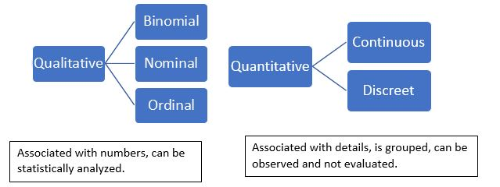

Binomial Data

Binomial is not Binary Data (0 or 1, True or False) and, generally, is the result of probability outcomes. For example, a series of trials resulting in either of two possible outcomes. Scenario: A Coin is flipped 100 times and the results are recorded. A Scatter Plot is used to show the distribution.

1#Generating Sample numbers

2> myseq <- seq(1,100,by = 1)

3> print(myseq)

r

1# Binomial distribution

2> BD <- dbinom(myseq,100,0.5)

3> print(BD)

r

1# Make a Scatter Plot.

2> plot (x = myseq, y = BD, xlab ="Probability",ylab="Observation number")

r

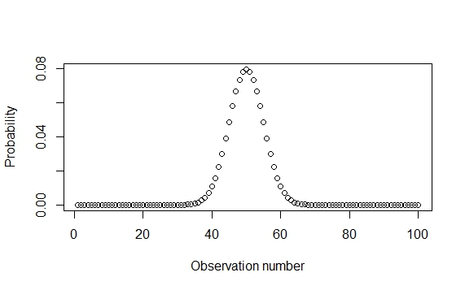

Nominal Data:

Values are allocated to distinct categories and have no meaningful order. For example, data about smoking habits can be categorized but not ordered. Scenario: Random data is generated to categorize gender. Pie charts are used to show the percentage values.

1#Generating dataset with Gender Values

2> Gender <- c("Male", "Female", "No Answer")

3> Gendervals <- table(sample(Gender,25,replace = TRUE, prob = c(0.25,0.50,0.25)))

r

1# Making a basic Pie chart

2> pie( Gendervals, Gender)

r

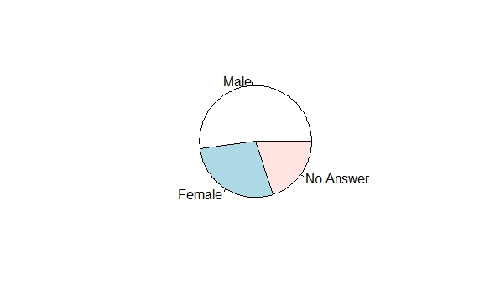

Ordinal Data

Nominal data that is ordered but there is no scale to measure the difference. The order or rank of the data is the distinctive feature of ordinal data. Scenario: Let us create dummy survey dataset for patients who were asked how often they get a headache and if the pain is high medium or low. We will make a Spine plot to show the results.

1#build a dataset for survey data for Frequency of headaches vs level of pain.

2> frequecyh <- rep(1:5, times = c(20, 38, 16, 72, 40))

3> levelpain <- c(rep(1:5, times = c(25, 17, 18, 02, 01)), #High

4 rep(1:5, times = c(20, 04, 21, 01, 02)), # Medium

5 rep(1:5, times = c(22, 03, 30, 03, 17))) #Low

6> levelp <- data.frame(frequecyh, levelpain)

7> plot(factor(levelpain)~factor(frequecyh), xlab= "Frequency of pain", ylab= "Level of Pain")

r

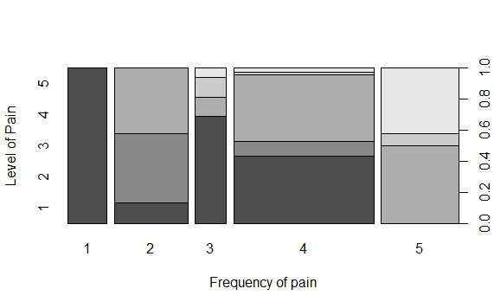

Continuous Data

Data that represents a range of information that can be divided into levels. To summarize, data that cannot be counted and has infinite values but is still measurable and can be subdivided. For example, Temperature, Humidity, Height, Weight, etc. are all measured in a given range.  
Scenario: Let us take the example of Beaver1 dataset and build a Histogram for the temperature values.

1> hist(beaver1$temp,xlab = "Temperature",ylab = "Range",main = "Beaver 1")

r

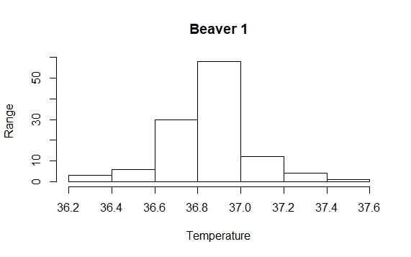

Discreet Data

Readings or the count of whole numbers that are limited. In simple terms, discreet data involves integers, a limited number of possible values, and cannot be divided into parts. For example, 50 employees, 3 laptops, 5 friends are all whole integers. Scenario: Let us take the example of mtcars dataset where the number of cylinders and gears is a whole number, hence a Bar plot can depict the relation between both.

1> x <- table(mtcars$gear,mtcars$cyl)

2> barplot(x, xlab = "No of cylinders", ylab = "Gears")

r

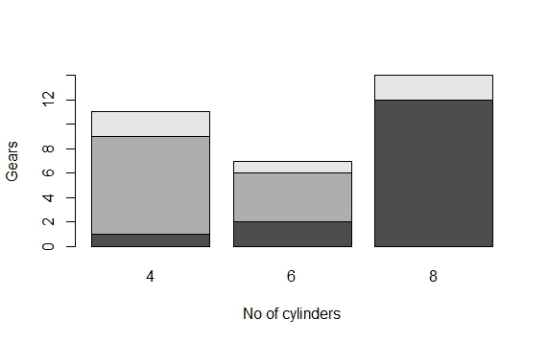

Is Your Data Univariate or Multivariate?

Univariate

*Univariate*: As the name suggests, Uni (one) and Variate (variable), data has a single variable or, in statistical terms, data composed of a single vector component. For example, temperature changes at a single point on different dates. Scenario: Let us see how the built-in dataset US Accidental deaths get represented in a line graph. It is a simple dataset with year, month, and the number of accidental deaths and is a good example of univariate data.

1# Univaraite Data

2> print (USAccDeaths)

3> plot(USAccDeaths type = 1)

r

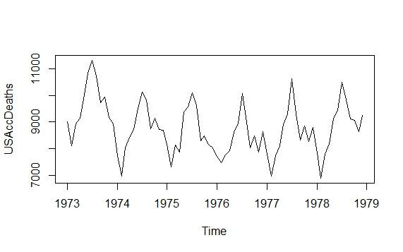

Multivariate

*Multivariate*: On the other hand, Multi (many) Variate (variables) are multiple variables in varied states. For example, the study of temperatures, humidity, and wind speed at different points and dates. Scenario: For this scenario lets us take iris dataset and we will use a scatter plot matrix.

1# iris data

2plot (iris)

r

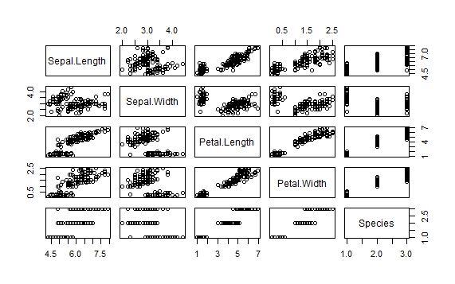

What Do You Want to Accomplish?

It is also important to keep focused on what you want to accomplish by the visualization. For example, you can make an area chart to study the relationship between variables and their behaviors and you can use a correlation plot to understand the relationship of variables based on the effect they have on each other. Similarly, you can compare values of the variables depending on criterion; for this, scatter plots and bubble charts can be considered. If the purpose is to study the composition of data, you can use pie charts or percentage charts.

In Conclusion

To summarize, the first step to visualization is to understand the data. The table below gives a quick summary of selecting a chart based on your data. If you are looking for simple, quick solutions use plot(), as it is intuitive and can handle common chart types.

|  |  |
| --- | --- |
| **Univariate** | **Multivariate** |
| Line Charts | Heat Maps |
| Dotted Line | Stacked Columns charts |
| Candle Stick | Box plot |
| Bar Charts | Bubble Charts |
| **Qualitative** | **Quantitative** |
| Bubble Charts | Waterfall Charts |
| Heat Maps | Line charts |
| Sankey Plots | Histograms |
| Pie Chart | Density Plot |
| Spatial Maps | Time Series Graphs |

|  |  |  |  |
| --- | --- | --- | --- |
| **Correlate** | **Compare** | **Composition** | **Distribution** |
| Scatter Plot / Bubble | Scatter Plot | Area Charts | Histograms |
| Dot Plot | Bar Plot / Candlestick | Density Plots | Area Charts |
| Sankey Plot | Axis Line /Dual Line | Waterfall Charts | Scatter Plot |
| Correlation Plot | Cohort Diagrams | Column Chart | Heat Maps |

28

Learn how to use [storytelling best practices](https://infogram.com/blog/moving-beyond-the-stock-photo-how-to-master-marketing-with-visual-storytelling/) to create stunning images and powerful presentations that drive audience engagement.

**Comparison**

Comparison charts are used to compare one or more datasets. They can compare items or show differences over time.

**Relationship**

Relationship charts are used to show a connection or correlation between two or more variables.

**Composition**

Composition charts are used to display parts of a whole and change over time.

**Distribution**

Distribution charts are used to show how variables are distributed over time, helping identify outliers and trends.

Selecting the right chart type

Ask yourself how many variables do you want to show, how many data points you want to display and how you want to scale your axis.

Line, bar and column charts represent change over time. Pyramids and pie charts display parts-of-a-whole. While scatter plots and treemaps are helpful if you have a lot of data to visualize.

Types of Charts

[Line Charts](https://infogram.com/create/line-chart)

[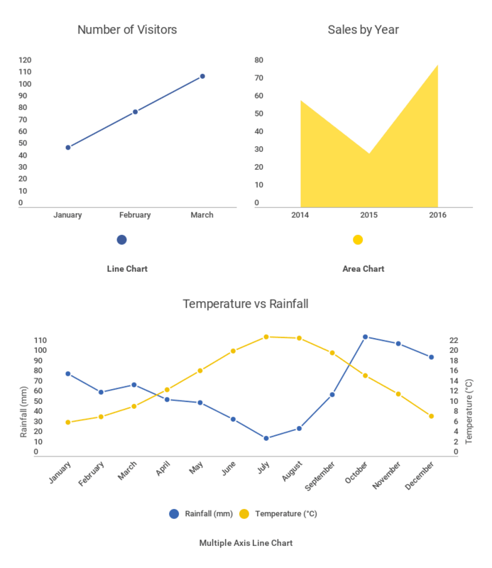](https://infogram.com/create/line-chart)

A line chart reveals trends or change over time. Line charts can be used to show relationships within a continuous data set, and can be applied to a wide variety of categories, including daily number of visitors to a site or variations in stock prices.

**Best practices for creating line charts:**

* Clearly label your axes - Make sure the viewer knows what they are evaluating.
* Remove distracting chart elements - Grids, varying colors, and bulky legends can distract the viewer from quickly seeing the overall trend.
* Zoom in on the y-axis if your data set starts above zero - In certain cases, changing the scale of the y axis makes it easier for.
* Avoid comparing more than 5-7 lines - You don't want your chart to become cluttered or hard to read. Visualize the data you need to tell your story, nothing more.

[Pie Charts](https://infogram.com/create/pie-chart)

[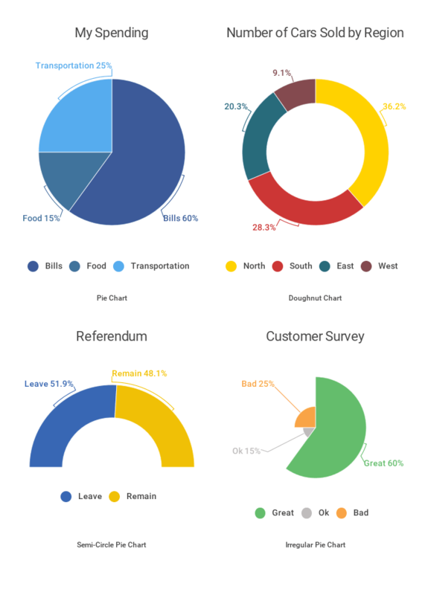](https://infogram.com/create/pie-chart)

The pie chart is one of the most used and hated chart types of all time. Pie charts are used to show parts of a whole. A pie chart represents numbers in percentages, and the total sum of all the divided segments equals 100 percent.

**Best practices for creating pie charts:**

* Make sure your segments add up to 100 - Sounds obvious, but this is a common mistake.
* Keep it clean and consistent. Compare just a few categories to get your point across. If the pie slices have roughly the same size, consider to use a bar or column chart instead.
* Avoid using 3-D imagery or tilt your pie chart - This often makes your data impossible to read, because your viewer is trying to quickly compare angles.

[Bar Charts](https://infogram.com/create/bar-graph) and [Column Charts](https://infogram.com/create/column-chart)

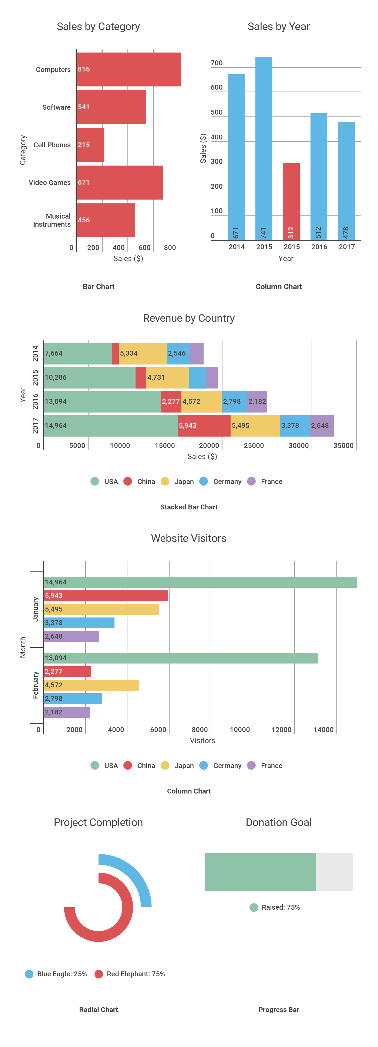

Bar and column charts are used to compare different items. Bars on a column chart are vertical while bars on a bar chart are horizontal. Bar charts are generally used to help avoid clutter when one data label is long or if you have more than 10 items to compare. They are easy to understand and to create.

**Best practices for creating bar and column charts:**

* Start the y-axis at zero - Our eyes are sensitive to the area of bars on a chart. If those bars are truncated, the viewer might draw the wrong conclusions.
* Label the axes - Labelling the axes gives your viewer context.
* Put value labels on bars - This helps to preserve the clean lines of the bar lengths.
* Avoid using too many colors "rainbow effect".  Using a single color, or varying shades of the same color, is a much better practice. You can highlight one bar in particular if that is the message you want to get across.

[Treemap](https://infogram.com/create/treemap)

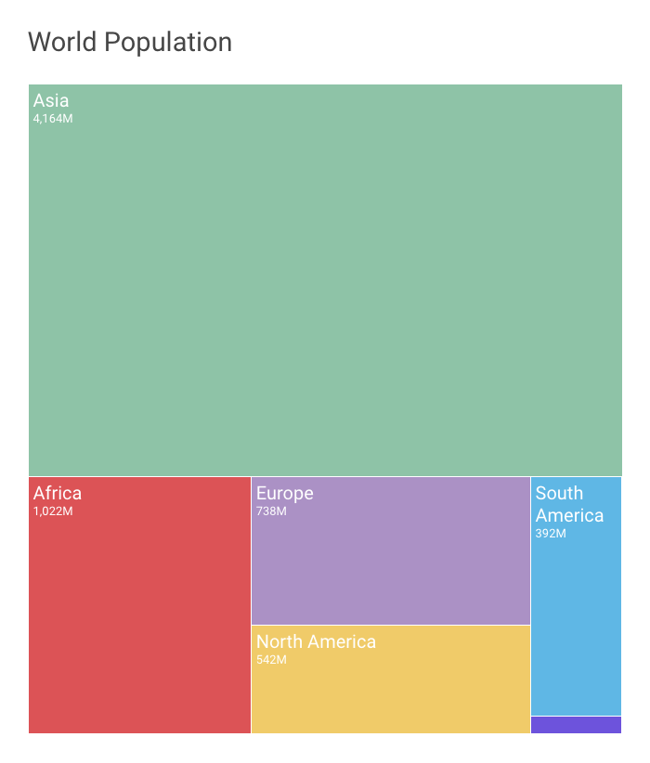

Treemaps show parts of a whole.  They display hierarchical information as a cluster of rectangles varying in size and color, depending on their data value.  The size of each rectangle represents a quantity, while the color can represent a number value or a category.

Treemaps allow you to view trends and make comparisons quickly – especially if one color is particularly prominent. While spreadsheets can show multiple rows of data, treemaps can accommodate hundreds of thousands of items in one organized display, making it easy to spot patterns in seconds. Plus, if made correctly, they make very efficient use of space.

**Best practices for creating a Treemap**

* Start with clean data and a clear message - Treemaps can often involve a lot of data, so it's important to know exactly what you want to highlight.
* Use bright, contrasting colors so each region is easily de ned - But, remember to avoid the 'rainbow e ect.' Choose your colors wisely.
* Label each region appropriately with text or numbers -  is makes it easier for the viewer to evaluate your treemap quickly, without error.
* Avoid clutter your treemap with too many boxes - Treemaps can contain any number of boxes, but space is limited! You don't want your treemap to be hard to read.

[Dual Axis Chart](https://infogram.com/create/dual-axis-chart)

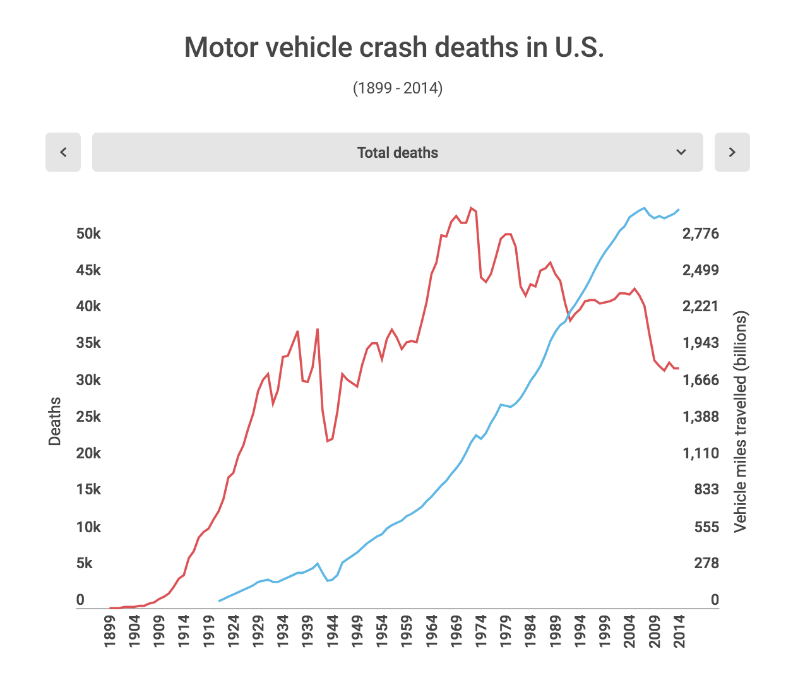

With a dual axis chart you are essentially combining multiple charts and adding a second y-axis for comparison. Some members of the data visualization community are skeptical about the use of dual axis charts because they can often be confusing, poorly designed, and misleading to the viewer.

Let’s go over the different types of dual axis charts and the best ways to use them:

**Column and Line Chart**– This dual axis chart combines a column chart with a line chart.

**Dual Line Chart** – This dual axis chart compares two line charts. There can be more than two lines if need be.

**Dual Column Chart**– This dual axis column chart shows two sets of data displayed side by side.

**Multiple Axes Chart** – This displays the most complex version of the dual axis chart. Here you see three sets of data – with three y-axes.

[Area Chart](https://infogram.com/create/area-chart)

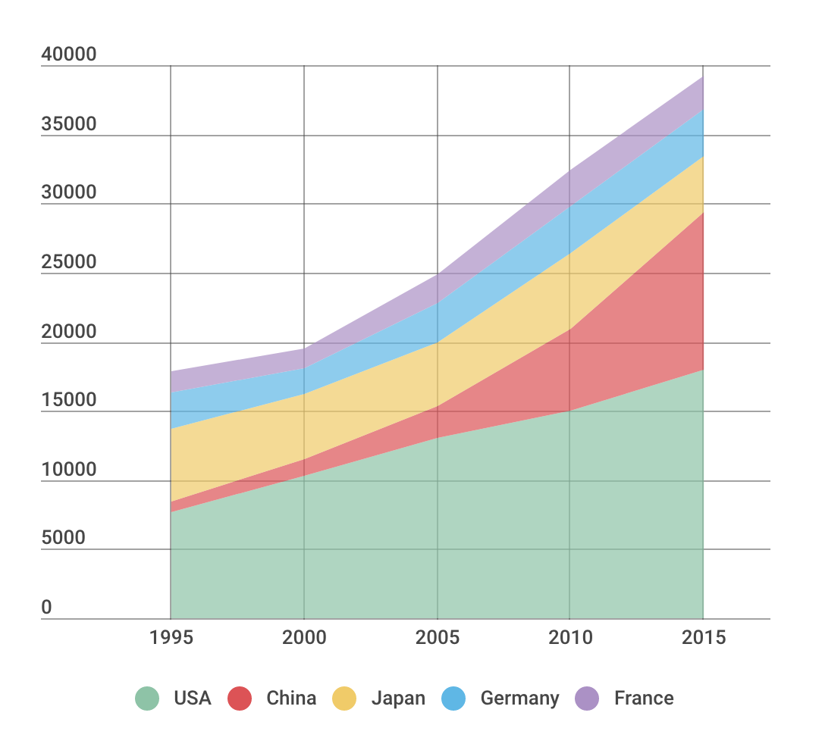

Area charts are a lot like line charts, with a few subtle differences. They can both show change over time, overall trends, and continuity across a dataset. But, while area charts may function the same way as line charts, the space between the line and axis is filled in, indicating volume.

**Best practices for creating Area charts**

* Make it easy to read - Avoid occlusion. This happens when one or more layers covers important information on the chart.
* Use a stacked area chart - If you have multiple data sets and want to emphasize part-to-whole relationships.
* Use area charts to look at the bigger picture - Take population for example: Line charts are good for showing net change in population over time, while area charts are good for showing the total population over time.
* Avoid comparing too many datasets.  Use instead a line chart, its cleaner.
* Give the proper context with appropriate labels and legends.

[Pyramid Chart](https://infogram.com/blog/pyramid-charts-build-the-foundation-for-success/)

[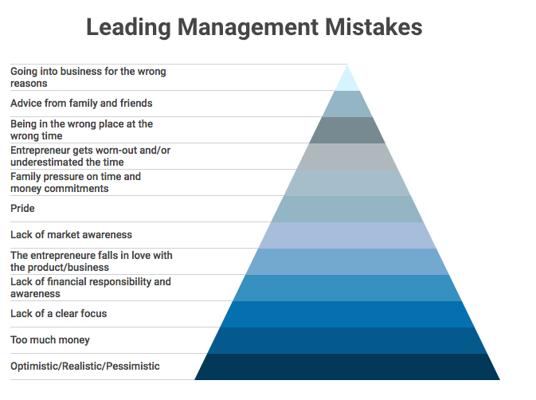](https://infogram.com/examples/charts/pyramid-chart)

Pyramid charts (triangle chart or triangle diagram) are a fun way to visualize foundation based relationships.  ey appear in the form of a triangle that has been divided into horizontal sections with categories labeled according to their hierarchy. They can be oriented up or down depending on the relationships they represent. The stacked layers can also show the order of steps in a particular process.

**Best practices for creating Pyramid Charts**

* Pick a topic and clearly label your subcategories - Decide what information you want to convey with your pyramid and clearly label your layers.
* Organize your subcategories - Decide the order and value of each section on your pyramid.
* Organize the subcategories based on their hierarchy.
* Be consistent - Keep the spacing of your sections even and pick a pleasing color palette.
* Keep subcategories to a minimum.  Adding many layers and colors can make your pyramid hard to read.

[Word Cloud](https://infogram.com/create/word-cloud)

[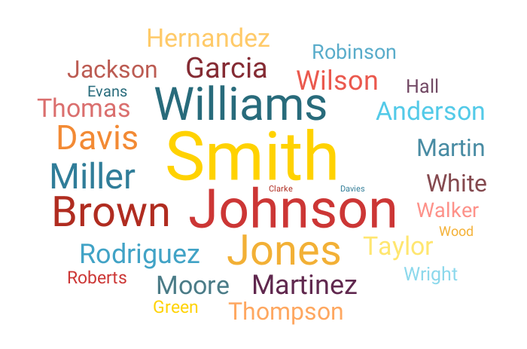](https://infogram.com/create/word-cloud)

Word clouds (also known as tag clouds) are a type of weighted list. Word clouds display text in varying font sizes, weight, or colors to show frequencies or categories. They can be arranged alphabetically or at random. They help people identify trends and patterns that might have been difficult to see otherwise.

**Best practices for creating a Word Cloud**

* Provide context - Word clouds are visually eye-catching and provide information about frequency but they often don't give the viewer any context.
* Use word clouds to show frequency - Avoid using them to display complex topics like the budget or healthcare crisis.
* Watch your word length - Longer words take up more space and can be misleading.
* Word clouds are great for filtering and analyzing data.
* Avoid making your words too similar in size or color.

[Tables](https://infogram.com/create/table)

[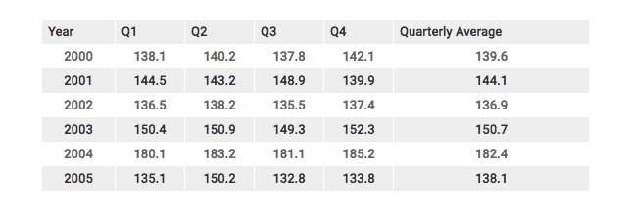](https://infogram.com/examples/charts/table)

Tables display data in rows and columns. Tables make it easy to compare pairs of related values or to display qualitative information (e.g. quarterly sales over several years).

There are multiple reasons you might select a [table over a graph](https://infogram.com/blog/do-you-know-when-to-use-tables-vs-charts/), as the right way to visualize your data.

**Best practices for creating reporting tables**

* Ask yourself how your table will be used and define your audience.
* Consider removing grid lines to increase readability.
* Always include the source(s) of your data
* Numbers should be aligned to the right, because it makes easier to compare. Text can be aligned left, but you might prefer to center it for readability.
* Use color or formatting to draw the viewer to specific values (cells) in your table.

**How to Choose the Right Data Visualization**

Posted by **Mike Yi, Mel Restori** on October 4, 2019

Data visualizations are a vital component of a data analysis, as they have the capability of summarizing large amounts of data efficiently in a graphical format. There are [many chart types available](https://chartio.com/learn/charts/essential-chart-types-for-data-visualization/), each with its own strengths and use cases. One of the trickiest parts of the analysis process is choosing the right way to represent your data using one of these visualizations.

In this article, we will approach the task of choosing a data visualization based on the type of task that you want to perform.

Common roles for data visualization include:

* showing change over time
* showing a part-to-whole composition
* looking at how data is distributed
* comparing values between groups
* observing relationships between variables
* looking at geographical data

The types of variables you are analyzing and the audience for the visualization can also affect which chart will work best within each role. Certain visualizations can also be used for multiple purposes depending on these factors.

**[Charts for showing change over time](https://chartio.com/learn/charts/how-to-choose-data-visualization/" \l "charts-for-showing-change-over-time)**

One of the most common applications for visualizing data is to see the change in value for a variable across time. These charts usually have time on the horizontal axis, moving from left to right, with the variable of interest’s values on the vertical axis. There are multiple ways of encoding these values:

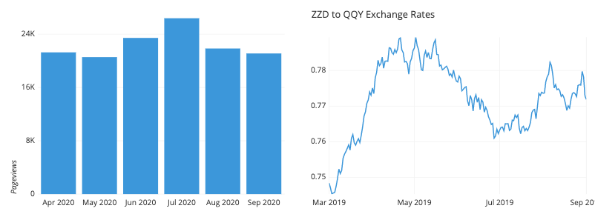

* [**Bar charts**](https://chartio.com/learn/charts/bar-chart-complete-guide/) encode value by the heights of bars from a baseline.
* [**Line charts**](https://chartio.com/learn/charts/line-chart-complete-guide/) encode value by the vertical positions of points connected by line segments. This is useful when a baseline is not meaningful, or if the number of bars would be overwhelming to plot.
* A [**box plot**](https://chartio.com/learn/charts/box-plot-complete-guide/) can be useful when a distribution of values need to be plotted for each time period; each set of box and whiskers can show where the most common data values lie.
* There are a number of specialist chart types for the financial domain, like the candlestick chart or Kagi chart.

**[Charts for showing part-to-whole composition](https://chartio.com/learn/charts/how-to-choose-data-visualization/" \l "charts-for-showing-part-to-whole-composition)**

Sometimes, we need to know not just a total, but the components that comprise that total. While other charts like a standard bar chart can be used to compare the values of the components, the following charts put the part-to-whole decomposition at the forefront:

Pie charts and stacked area charts are among the chart types that can be used to show part-to-whole comparisons.

* The [**pie chart**](https://chartio.com/learn/charts/pie-chart-complete-guide/) and cousin donut chart represent the whole with a circle, divided by slices into parts.
* A [**stacked bar chart**](https://chartio.com/learn/charts/stacked-bar-chart-complete-guide/) modifies a bar chart by dividing each bar into multiple sub-bars, showing a part-to-whole composition within each primary bar.
* Similarly, a [**stacked area chart**](https://chartio.com/learn/charts/area-chart-complete-guide/) modifies the line chart by using shading under the line to divide the total into sub-group values.
* A host of other more intricate chart types have also been developed to show hierarchical relationships. These include the Marimekko plot and treemap.

**[Charts for looking at how data is distributed](https://chartio.com/learn/charts/how-to-choose-data-visualization/" \l "charts-for-looking-at-how-data-is-distributed)**

One important use for visualizations is to show how data points’ values are distributed. This is particularly useful during the exploration process, when trying to build an understanding of the properties of data features.

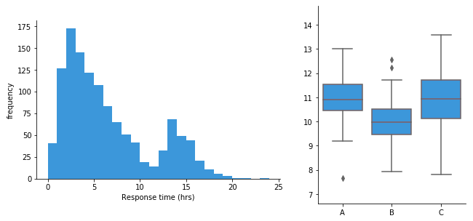

* [**Bar charts**](https://chartio.com/learn/charts/bar-chart-complete-guide/) are used when a variable is qualitative and takes a number of discrete values.
* A [**histogram**](https://chartio.com/learn/charts/histogram-complete-guide/) is used when a variable is quantitative, taking numeric values.
* Alternatively, a **density curve** can be used in place of a histogram, as a smoothed estimate of the underlying distribution.
* A [**violin plot**](https://chartio.com/learn/charts/violin-plot-complete-guide/) compares numeric value distributions between groups by plotting a density curve for each group.
* The [**box plot**](https://chartio.com/learn/charts/box-plot-complete-guide/) is another way of comparing distributions between groups, but with a summary of statistics rather than an estimated distributional shape.

**[Charts for comparing values between groups](https://chartio.com/learn/charts/how-to-choose-data-visualization/" \l "charts-for-comparing-values-between-groups)**

Another very common application for a data visualization is to compare values between distinct groups. This is frequently combined with other roles for data visualization, like showing change over time, or looking at how data is distributed.

dot-plots-grouped-bar-chats

* A [**bar chart**](https://chartio.com/learn/charts/bar-chart-complete-guide/) compares values between groups by assigning a bar to each group.
* A **dot plot** can be used similarly, except with value indicated by point positions instead of bar lengths. This is like a line chart with the line segments removed, eliminating the ‘connection’ between sequential points. Also like a line chart, a dot plot is useful when including a vertical baseline would not be meaningful.
* A [**line chart**](https://chartio.com/learn/charts/line-chart-complete-guide/) can be used to compare values between groups across time by plotting one line per group.
* A [**grouped bar chart**](https://chartio.com/learn/charts/grouped-bar-chart-complete-guide/) allows for comparison of data across two different grouping variables by plotting multiple bars at each location, not just one.
* [**Violin plots**](https://chartio.com/learn/charts/violin-plot-complete-guide/) and [**box plots**](https://chartio.com/learn/charts/box-plot-complete-guide/) are used to compare data distributions between groups.
* A [**funnel chart**](https://chartio.com/learn/charts/funnel-chart-complete-guide/) is a specialist chart for showing how quantities move through a process, like tracking how many visitors get from being shown an ad to eventually making a purchase.
* **Bullet charts** are another specialist chart for comparing a true value to one or more benchmarks.
* One sub-category of charts comes from the comparison of values between groups for multiple attributes. Examples of these charts include the parallel coordinates plot (and its special case the slope plot), and the dumbbell plot.

**[Charts for observing relationships between variables](https://chartio.com/learn/charts/how-to-choose-data-visualization/" \l "charts-for-observing-relationships-between-variables)**

Another task that shows up in data exploration is understanding the relationship between data features. The chart types below can be used to plot two or more variables against one another to observe trends and patterns between them.

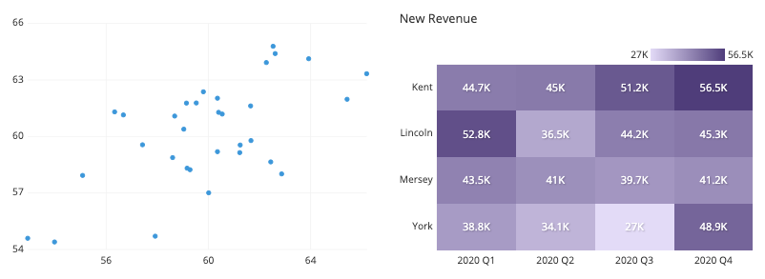

* The [**scatter plot**](https://chartio.com/learn/charts/what-is-a-scatter-plot/) is the standard way of showing the relationship between two variables.
* Scatter plots can also be expanded to additional variables by adding color, shape, or size to each point as indicators, as in a [**bubble chart**](https://chartio.com/learn/charts/bubble-chart-complete-guide/).
* When a third variable represents time, points in a scatter plot can be connected with line segments, generating a **connected scatter plot**.
* Another alternative for a temporal third-variable is a **dual-axis plot**, such as plotting a line chart and bar chart with a shared horizontal axis.
* When one or both variables being compared are not numeric, a **[heatmap](https://chartio.com/learn/charts/heatmap-complete-guide/)** can show the relationship between groups. Heatmaps can also be used for purely numeric data, like in a 2-d histogram or 2-d density curve.

**[Charts for looking at geographical data](https://chartio.com/learn/charts/how-to-choose-data-visualization/" \l "charts-for-looking-at-geographical-data)**

Sometimes, data includes geographical data like latitude and longitude or regions like country or state. While plotting this data might just be extending an existing visualization onto a map background (e.g. plotting points like in a scatter plot on top of a map), there are other chart types that take the mapping domain into account. Two of these are highlighted below:

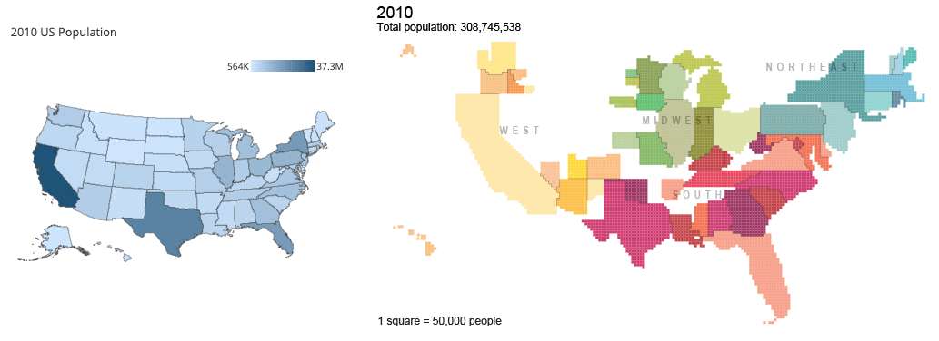Right: Cartogram of US Population from [census.gov](https://www.census.gov/dataviz/visualizations/021/)

* A **choropleth** is like a heatmap that colors in geopolitical regions rather than a strict grid.
* **Cartograms** take a different approach by using the size of each region to encode value. This approach necessitates some distortion in shapes and topology.

**[Closing thoughts](https://chartio.com/learn/charts/how-to-choose-data-visualization/" \l "closing-thoughts)**

Choosing the right chart for the job depends on the kinds of variables that you are looking at and what you want to get out of them. The above is only a general guideline: it is possible that breaking out of the standard modes will help you gain additional insights. Experiment with not just different chart types, but also how the variables are encoded in each chart. It’s also good to keep in mind that you aren’t limited to showing everything in just one plot. Often it is better to keep each individual plot as simple and clear as possible, and instead use multiple plots to make comparisons, show trends, and demonstrate relationships between multiple variables.

For a handy reference guide with additional chart types and more details of when they should be used, check out our free eBook, [How to Choose the Right Data Visualization](https://landing.chartio.com/ebook-how-to-choose-the-right-data-visualization).

Choose the Right Chart Type for Your Data

*Version: 2021.2*

What chart or graph works best for your data? In Tableau, form follows function. The visualization (or viz) you create depends on:

* The questions you are trying to ask
* The properties of your data
* How you want to present and communicate your insights to others

For example, showing the growth in sales each year requires a different visualization than showing the connection between discounted items and their profitability. Knowing what you need to show will help determine how you want to show it.

This topic presents nine different types of information that you can display with a visualization. This isn't a comprehensive list, and there are bound to be exceptions to these categories. With experience you will be able to more quickly assess what chart type you want to create. Because Tableau is flexible, we encourage you to think outside the box. However, before you think outside the box, it's helpful to start with some common chart types.

|  |  |
| --- | --- |
| Change over time  https://help.tableau.com/current/pro/desktop/en-us/Img/whatchart_change_over_time_header.png  Related topics   * [Building Line Charts](https://help.tableau.com/current/pro/desktop/en-us/buildexamples_line.htm) * [Dates and Times](https://help.tableau.com/current/pro/desktop/en-us/dates.htm) * [Continuous Dates](https://help.tableau.com/current/pro/desktop/en-us/dates_continuous.htm) | Showing a change over time for a measure is one of the fundamental categories of visualizations. There are many options for exploring change over time, including line charts, slope charts, and highlight tables.  To show change over time, you need to know the value you expect to change, and how to work with Date fields in Tableau.  What kind of question does this chart answer?   * How has this measure changed in the past year? * When did this measure change? * How quickly has this measure changed?   More inspiration   * [Understand change over time with time-series analysis(Link opens in a new window)](https://www.tableau.com/solutions/workbook/day-of-week-analysis) * [New Ways to Visualize Time(Link opens in a new window)](https://youtu.be/iDll2j1Izts) * [Visualizing Time: Beyond the Line Chart(Link opens in a new window)](https://www.tableau.com/learn/whitepapers/visualizing-time-beyond-line-chart) * [Examples of Change Over Time(Link opens in a new window)](https://public.tableau.com/views/VisualVocabulary/ChangeoverTime) |
| Correlation  https://help.tableau.com/current/pro/desktop/en-us/Img/whatchart_correllation_header.png  Related topics   * [Build a Scatter Plot](https://help.tableau.com/current/pro/desktop/en-us/buildexamples_scatter.htm) * [Create Heatmaps that Show Trends or Density in Tableau(Link opens in a new window)](https://help.tableau.com/current/pro/desktop/en-us/maps_howto_heatmap.htm) * [Add Trend Lines to a Visualization](https://help.tableau.com/current/pro/desktop/en-us/trendlines_add.htm) | Sometimes you have two variables and are looking for the relationship between them. For example, you may be looking for the relationship between classroom size and school graduation rate, or how much lung capacity relates to endurance. (But remember, correlation does not always equal causation.)  Correlation can be shown with scatter plots or highlight tables, and you can use Tableau's [analytics objects(Link opens in a new window)](https://help.tableau.com/current/pro/desktop/en-us/environ_workspace_analytics_pane.htm) to show the strength of the correlation.  What types of question can this chart answer?   * Are these two measures related? How strongly? * Are some measures more related than others? * How strongly related are these measures? |
| Magnitude  https://help.tableau.com/current/pro/desktop/en-us/Img/whatchart_magnitude_header.png  Related topics   * [Build a Bar Chart](https://help.tableau.com/current/pro/desktop/en-us/buildexamples_bar.htm) * [Build a Packed Bubble Chart](https://help.tableau.com/current/pro/desktop/en-us/buildexamples_bubbles.htm) * [Building Line Charts](https://help.tableau.com/current/pro/desktop/en-us/buildexamples_line.htm) | Magnitude shows the relative size or value of two or more discrete items. If you are comparing sales for different regions, you are looking at magnitude.  Magnitude charts include bar charts, packed bubble charts, and line charts.  What types of question can this chart answer?   * Which of these dimension members has the highest measure? * Are there any exceptional dimensions? * How large of a gap is there between the lowest and highest measure between these dimensions? |
| Deviation  https://help.tableau.com/current/pro/desktop/en-us/Img/whatchart_divergence_header.png  Related topics   * [Build a Bar Chart](https://help.tableau.com/current/pro/desktop/en-us/buildexamples_bar.htm) * [Build a Bullet Graph](https://help.tableau.com/current/pro/desktop/en-us/qs_bullet_graphs.htm) * [Calculate Z-scores](https://help.tableau.com/current/pro/desktop/en-us/calculating_z_scores.htm) | Deviation charts show how far a value varies from some baseline, such as the average or median. If you wanted to know which items had unusually high or low profit margins, you would use a deviation chart.  You can use bullet charts, bar charts, and combination charts to show deviation. You can also find the statistical significance of the deviation using a Z-score.  What types of question can this chart answer?   * How far from the norm does this measure stray? * How important are the deviations in this measure? * Is there a pattern to the deviations? |
| Distribution  https://help.tableau.com/current/pro/desktop/en-us/Img/whatchart_distribution_header.png  Related topics   * [Build a Histogram](https://help.tableau.com/current/pro/desktop/en-us/buildexamples_histogram.htm) * [Build a Box Plot](https://help.tableau.com/current/pro/desktop/en-us/buildexamples_boxplot.htm) * [Create a Pareto Chart](https://help.tableau.com/current/pro/desktop/en-us/pareto.htm) * [Create a Population Pyramid](https://help.tableau.com/current/pro/desktop/en-us/population_pyramid.htm) | When you are trying to find the frequency of events within a population, you are looking at the distribution. If you are showing the number of respondents to a survey by age, or the frequency of incoming calls by day, a distribution chart might be the best choice.  Distribution charts include histograms, population pyramids, Pareto charts, and box plots.  What types of question can this chart answer?   * Are events clustered around a certain probability? * Which population group buys the most items? * When are the busiest times in our work day? |
| Ranking  https://help.tableau.com/current/pro/desktop/en-us/Img/whatchart_ranking_header.png  Related topics   * [Build a Bar Chart](https://help.tableau.com/current/pro/desktop/en-us/buildexamples_bar.htm) * [Table Calculation Types](https://help.tableau.com/current/pro/desktop/en-us/calculations_tablecalculations_definebasic_runningtotal.htm) * [Sets for Top N and Others](https://help.tableau.com/current/pro/desktop/en-us/sortgroup_sets_topn.htm) * [Visualize Key Progress Indicators](https://help.tableau.com/current/pro/desktop/en-us/kpi.htm) | Sometimes you not only want to depict the magnitude of some value, but also the relative ranking of all the members of your dimension. Showing the top ten sales people or demonstrating the under-performing states use a ranking chart.  Ranking charts are usually bar charts that integrate rank calculations, top n sets, or key progress indicators.  What types of question can this chart answer?   * How many people are under-performing in the company? * How much revenue is generated by our top ten customers? * What is the value of our ten lowest revenue properties? |
| Part-to-Whole  https://help.tableau.com/current/pro/desktop/en-us/Img/whatchart_parttowhole_header.png  Related topics   * [Build a Pie Chart](https://help.tableau.com/current/pro/desktop/en-us/buildexamples_pie.htm) * [Build a Treemap](https://help.tableau.com/current/pro/desktop/en-us/buildexamples_treemap.htm) * [Create an Area Chart](https://help.tableau.com/current/pro/desktop/en-us/qs_area_charts.htm) * [Stack Marks](https://help.tableau.com/current/pro/desktop/en-us/viewparts_marks_stacking.htm) | Part-to-Whole charts show how much of a whole an individual part takes up. For example, if you are showing how much each region contributes to overall sales, or how expensive each different shipping mode is for an individual product, you would use a part to whole chart.  Part-to-Whole charts can be pie charts, area charts, stacked bar charts, or treemaps.  What types of question can this chart answer?   * How much does this value contribute to the total? * How does the distribution of costs change each year? * Do different items contribute different amounts to sales by region? |
| Spatial  https://help.tableau.com/current/pro/desktop/en-us/Img/whatchart_spatial_header.png  Related topics   * [Build a Simple Map](https://help.tableau.com/current/pro/desktop/en-us/maps_howto_simple.htm) * [Create Maps that Show Quantitative Values in Tableau](https://help.tableau.com/current/pro/desktop/en-us/maps_howto_symbol.htm) * [Create Maps that Highlight Visual Clusters of Data in Tableau](https://help.tableau.com/current/pro/desktop/en-us/maps_howto_pointdistribution.htm) | Spatial charts can precise locations and geographical patterns in your data. Showing the airport terminals with the most foot traffic or a map of all sales across the country are examples of spatial maps.  Spatial maps include filled maps, point distribution maps, symbol maps, and density maps.  What types of question can this chart answer?   * Which city has the highest sales? * How far from distribution centers are our customers? * How many people arrive at which gate? |
| Flow  https://help.tableau.com/current/pro/desktop/en-us/Img/maps_build9.png  Related topics   * [Create Maps that Show Paths Between Origins and Destinations in Tableau](https://help.tableau.com/current/pro/desktop/en-us/maps_howto_origin_destination.htm) * [Create Maps that Show a Path Over Time in Tableau](https://help.tableau.com/current/pro/desktop/en-us/maps_howto_flow.htm) | Flow charts can be maps that convey movement over time, such as Sankey diagrams. Flow maps include path over time and path between origin and destination charts.  What types of question can this chart answer?   * What is the longest shipping route? * How long are people lingering around gates? * What are the bottlenecks to traffic in the city? |

Related resources

For related content and examples of different types of visualizations you can create with Tableau, see:

* [Build Common Chart Types in Data Views(Link opens in a new window)](https://help.tableau.com/current/pro/desktop/en-us/dataview_examples.htm) and [Build Advanced Chart Types](https://help.tableau.com/current/pro/desktop/en-us/analytics_howtos.htm) in Tableau help.
* [Which Chart or Graph is Right for You?(Link opens in a new window)](https://www.tableau.com/learn/whitepapers/which-chart-or-graph-is-right-for-you) whitepaper on the Tableau website. Use your tableau.com account to sign in.
* [Visual Vocabulary(Link opens in a new window)](https://public.tableau.com/views/VisualVocabulary/VisualVocabulary) on Tableau Public by Tableau Zen Master [Andy Kriebel(Link opens in a new window)](https://www.theinformationlab.co.uk/2018/08/31/visual-vocabulary/) (also see [Andy's blog(Link opens in a new window)](http://www.vizwiz.com/2018/07/visual-vocabulary.html)).

Also see these free training videos and presentations:

* Andy Cotgreave's [Best of the Tableau Web(Link opens in a new window)](https://www.tableau.com/about/blog/contributors/andy-cotgreave-2) and other blog posts on tableau.com.
* [Getting Started with Visual Analytics(Link opens in a new window)](https://www.tableau.com/learn/tutorials/on-demand/getting-started-visual-analytics) (6 minutes) video tutorial. Use your tableau.com account to sign in. Also see different chart types under the [How To(Link opens in a new window)](https://www.tableau.com/learn/training#how-to) category on the Free Training Videos page.
* [Secrets of Visual Analytics(Link opens in a new window)](https://www.tableau.com/learn/series/secrets-of-visual-analytics) This four-part, on-demand webinar series introduces how to use Tableau for visual analytics. Use your tableau.com account to sign in.
* [Travel Tips for Your Visual Analysis Journey(Link opens in a new window)](https://youtu.be/qF5_OKiXplc) (50 minutes) video presentation from Tableau Conference.